

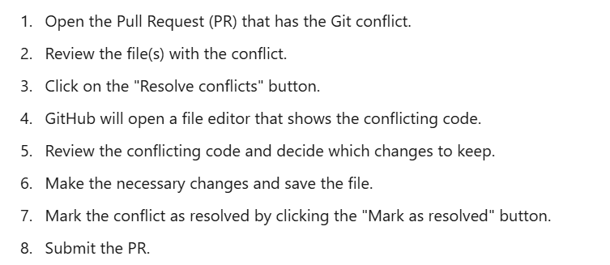

**Like That we can fix merge conflicts in Git**

**OR**

**We can avoid merge conflicts by using**

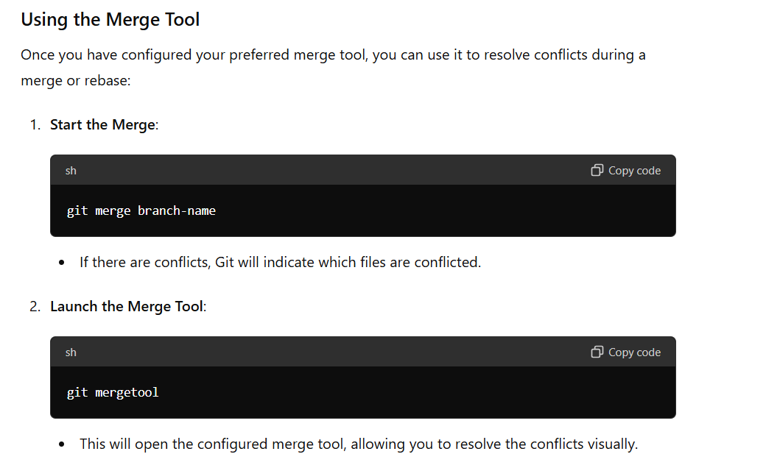

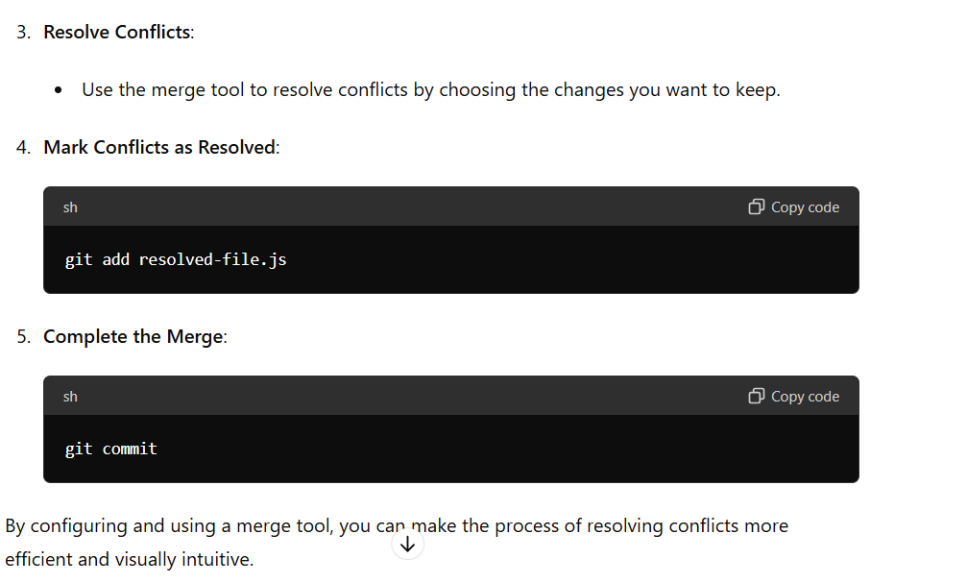

**Like That we can fix merge conflicts in Git**

[(26) Mastering Git Conflicts: How to Fix and Avoid Conflicts on GitHub and Git | LinkedIn](https://www.linkedin.com/pulse/mastering-git-conflicts-how-fix-avoid-github-raed-fadhlaoui/)